Assignment-16.3
Task Description #1 – Schema Generation
Task: Ask AI to design a schema for a Library Management System
(Tables: Books, Members, Loans)

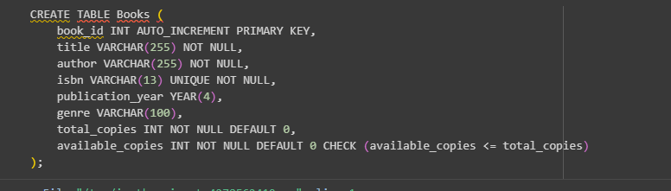
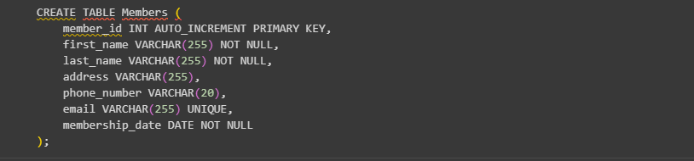
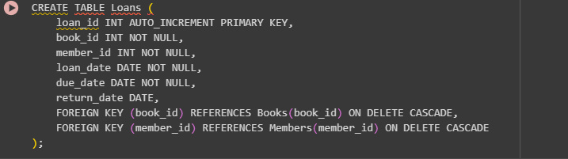

Task Description #2 – Error Insert Data
Task: Ask AI to generate INSERT INTO queries for the schema above
(3 sample records per table)
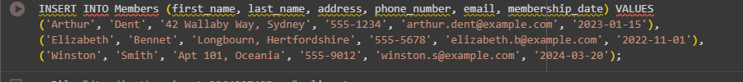
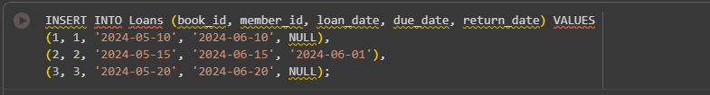

Task Description #3 – Basic Queries
Task: Use AI to generate a query to list all books borrowed by a specific
member
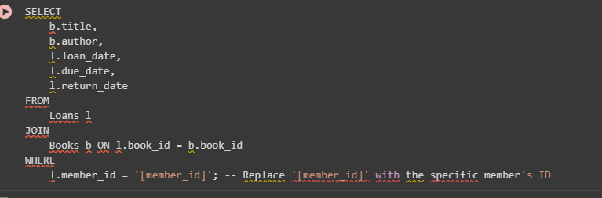

Task Description #4 – Update and Delete Queries
Task: Generate queries with AI for:
• Updating a book’s availability to FALSE when borrowed.
• Deleting a member record safely.
